# Assignment 02

# INPUT AND OUTPUT

Q1. Write a Java program to print 'Hello' on screen and your name on a separate line.

Source Code

class Q1 {

public static void main(String[] args) {

System.out.println(" Hello");

System.out.println(" Ram Lovewanshi");

}

}

OUTPUT

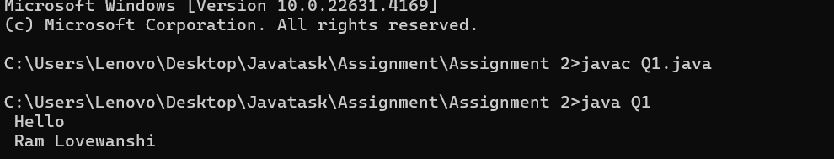

Q2. Write a Java program to print the sum of two numbers.

SOURCE CODE

class Q2 {

public static void main(String[] args) {

int a,b,c;

a=74;

b=36;

c=a+b;

System.out.println(c);

}

}

OUTPUT

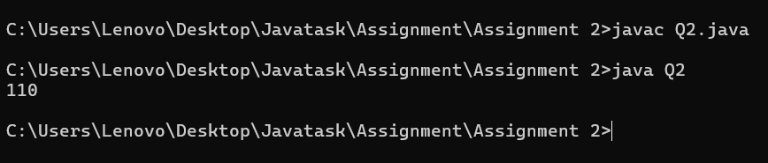

Q3. Write a Java program to divide two numbers and print them on the screen.

SOURCE CODE

class Q3 {

public static void main(String[] args) {

int a,b,c;

a=50;

b=3;

c=a/b;

System.out.println(c);

}

}

OUTPUT

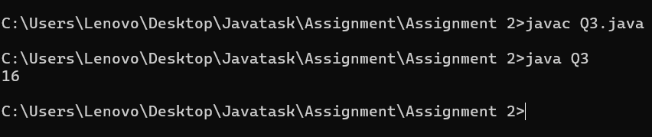

Q4. Write a Java program to print the results of the following operations.

SOURCE CODE

class Q4{

public static void main(String[] args) {

System.out.println(-5 + 8 * 6);

System.out.println((55+9) % 9);

System.out.println(20 + -3*5 / 8);

System.out.println(5 + 15 / 3 * 2 - 8 % 3);

}

}

OUTPUT

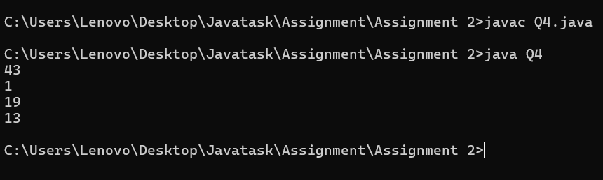

Q5. Write a Java program that takes two numbers as input and displays the product of two numbers.

SOURCE

import java.util.Scanner;

class Q5{

public static void main(String[] args) {

int a,b;

Scanner sc = new Scanner(System.in);

System.out.print("ENTER FIRST NUMBER ");

a=sc.nextInt();

System.out.print("ENTER SECOND NUMBER ");

b=sc.nextInt();

System.out.println(a + " X " + b + " = " + a*b);

}

}

OUTPUT

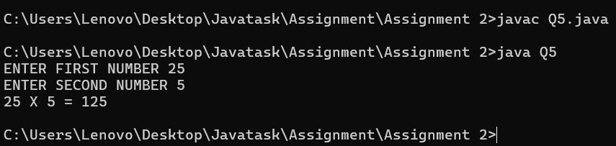

Q6. Write a Java program to print the sum (addition), multiply, subtract, divide and remainder of two numbers.

SOURCE CODE

import java.util.Scanner;

class Q6{

    public static void main(String[] args) {

        int a,b;

        Scanner sc = new Scanner(System.in);

        System.out.print("ENTER FIRST NUMBER ");

        a=sc.nextInt();

        System.out.print("ENTER SECOND NUMBER ");

        b=sc.nextInt();

        int c = a-b;

        System.out.println(a + " X " + b + " = " + a*b);

        System.out.println(a + " + " + b + " = " + a+b);

        System.out.println(a + " - " + b + " = " + c);

        System.out.println(a + " / " + b + " = " + a/b);

        System.out.println(a + " MOD " + b + " = " + a%b);

    }

}

OUTPUT

